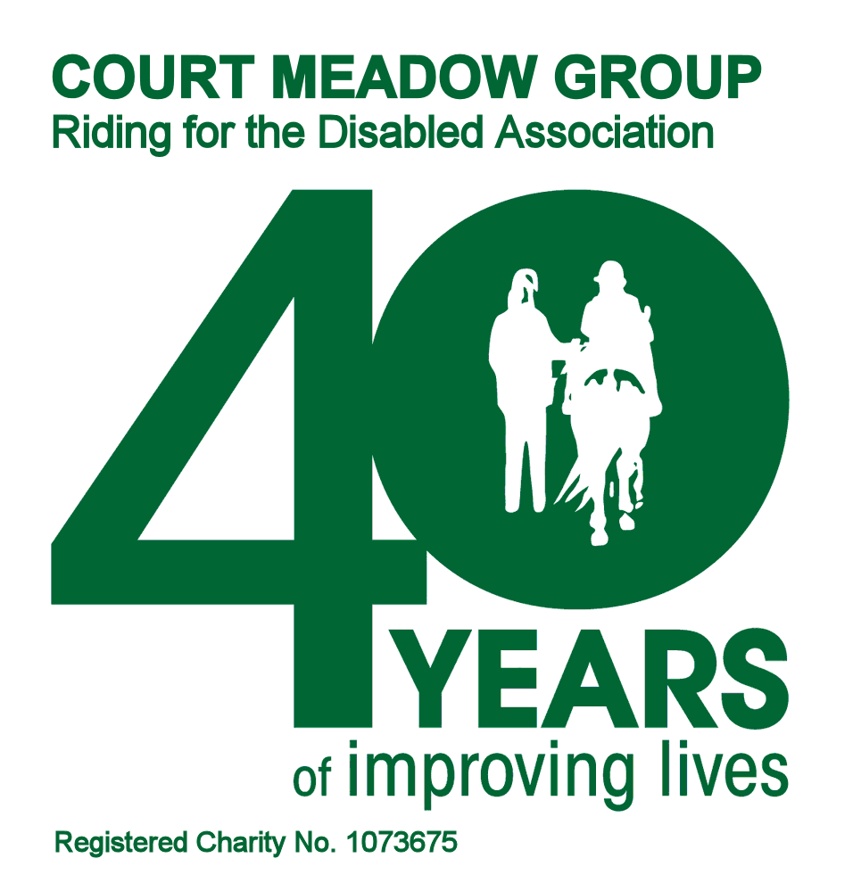
Application Form for Charity Golf Day
to be held on

Friday 31st May 2019

in aid of
Court Meadow Group
Riding for the Disabled Association
Registered Charity No. 1073675

Mid Sussex Golf Club, Spatham Lane, Ditchling, East Sussex BN6 8XJ
Tel: 01273 846567 Fax: 01273 847815

Closing Date Monday 13th May 2019

Details of the Day:
Coffee and Bacon Rolls available from 8am
9am – Shotgun start – 18 holes
1.30pm - Lunch (please tick your choice) and Prize-Giving

As with all Golf Clubs, Mid Sussex ask that:
Proper golf shoes are worn and dress code is adhered to
All are aware of the standard etiquettes of golf
All keep up with the speed of play
No trollies or buggies are to be driven onto the tees, greens or fringes.
If buggies are required, please arrange this direct with Mid Sussex Golf Club.

Please complete the following application form and return either with your cheque for £70 per player (name and address on the reverse) made payable to Court Meadow Group RDA to: Babs Malins, Compt Hill, Plumpton Road, North Chailey, East Sussex BN8 4EJ
Or email the form to: bandbmalins@gmail.com and pay by BACs transfer to Lloyds Bank Sort code: 30-18-30
Court Meadow Group Riding for the Disabled, a/c: 00951461 Ref. GOLF.

Enquiries: 01444 471165 www.courtmeadow-rda.org.uk

Name ……………………………………………………………………………………………………………..Handicap …………
Application Form for Charity Golf Day
to be held on

Friday 31st May 2019

Contact phone:………………………………………..

Email: ………………………………………..
Lunch (please select): Ham Egg & Chips ☐ Ploughmans ☐

If playing with others, please include their details below

Name …………………………………………………………………………………………………………….Handicap …………

Contact phone:………………………………………..

Email: ………………………………………..
Lunch (please select): Ham Egg & Chips ☐ Ploughmans ☐
Name ……………………………………………………………………………………………………….……Handicap …………

Contact phone:………………………………………..

Email: ………………………………………..
Lunch (please select): Ham Egg & Chips ☐ Ploughmans ☐

Name …………………………………………………………………………………………………………….Handicap …………

Contact phone:………………………………………..

Email: ………………………………………..
Lunch (please select): Ham Egg & Chips ☐ Ploughmans ☐

Please return to: Babs Malins, Compt Hill, Plumpton Road, North Chailey, East Sussex BN8 4EJ bandbmalins@gmail.com

Any final details will be sent out after the closing date. Thank you for your application – we look forward to seeing you on the day.

